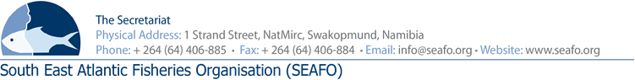
PROVISIONAL AGENDA FOR THE 16TH MEETING OF THE COMMISSION (COM) – 2019

CHAIRPERSON: Mr. Venâncio Soares Gomes (Angola 2017-2020) VENUE: Strand Hotel, Swakopmund
VICE-CHAIR: Mr. Luis Molledo (EU 2017-2020) DATE: 25 & 28 November 2019

Item | Agenda Item | Working Document
1 | Opening of meeting by Chairperson
2 | Appointment of rapporteur
3 | Adoption of Agenda and meeting arrangements | DOC/COM/00/2019  DOC/COM/01/2019  DOC/COM/02/2019
4 | Introduction & Admission of Observers
5 | Opening statements by Contracting Parties
6 | Status of the Convention in respect of membership
7 | Discussion on future biennial Commission meetings
8 | Report of the 2019 Scientific Committee meeting | DOC/COM/03/2019  DOC/COM/09/2019
9 | Report of the 2019 Compliance Committee meeting | DOC/COM/04/2019
10 | Report of the 2019 Standing Committee on Administration & Finance meeting | DOC/COM/05/2019
11 | Report on meetings attended by Secretariat | DOC/COM/06/2019  DOC/COM/07/2019
12 | Reports of SEAFO’s representatives at other intergovernmental organisation meetings
13 | Nomination of Parties representing SEAFO at intergovernmental organisations
14 | Any other matters | DOC/COM/08/2019  DOC/COM/10/2019  DOC/COM/11/2019
15 | Venue & date of next meeting
16 | Adoption of the 2019 Commission Report | DOC/COM/12/2019
17 | Closure of meeting

Circulation Date: 25 October 2019

